ENHANCING CLOUD INSIDER THREAT DETECTION USING ILSTM WITH COMPARABLE USER BEHAVIOR AND BLOCKCHAIN

ArunKumar.N¹
Assistance Professor
(Department of computer science)
Karpagam Academy of Higher Education
(Deemed to be university)
Coimbatore-641021
arunkumar.nagarajan@kahedu.edu.in¹
Rohini.V²
PG Student²
(Department of Computer Science²)
Karpagam Academy of Higher Education
(Deemed to be university)
Coimbatore-641021
rohinivellaichamy27@gmail.com²

Abstract— The open environment of cloud computing renders insider threats or malicious activities of authorized users a big problem to the integrity and trust of data. In this work, it is suggested to use a Blockchain-Assisted Improvised Long Short-Term Memory (ILSTM) construct which can be defined as the framework that improves the detection accuracy with the help of Comparison Layer on the basis of Comparable User Behavior Database (CUDB) and blockchain-powered trust auditing. The model tracks the activities of the user, fishes out behavioral characteristics, and compares them to the verified profiles to identify anomalies, and blockchain securely stores the scores of trust and logs. On a test set of synthetic cloud activity data (20,000 records) experimental evaluation resulted in a 96% detection accuracy and 5% false positive rate, which was better than conventional LSTM models. The hybrid ILSTM-Blockchain scheme is associated with traceability, tamper-proof detection, and forensic reliability, which is a long-term solution to mitigating the modern cloud insider threat.
Keywords— Insider Threat Detection, Improvised Long Short-Term Memory ( ILSTM),Comparable User Behavior Database ( CUDB ) Blockchain, Cloud Security, Trust Factor,Smart Contracts

I.INTRODUCTION
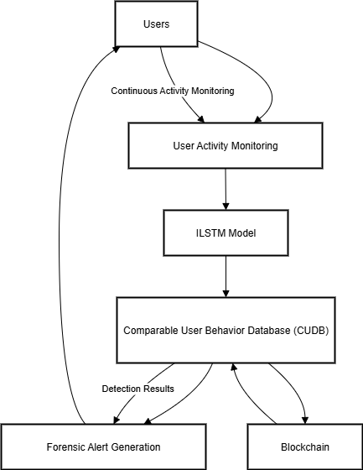
In spite of the developments of the anomaly-based security mechanisms, insider threats have not been extensively studied because they replicate the behavior of legitimate users. The conventional ML techniques need all the history records, and it makes them not that flexible to new or failed nodes. To address this, the proposed ILSTM and blockchain-based CUDB comparison enables integrity of detection, verifiability as well as lower false positives in dynamic cloud environments. The possibility to store, process, and share information easily has made cloud computing the lifeline of most businesses because it is scalable, affordable, and readily available.[1] The dependence on the cloud-based service, however, has led to insider threats as a significant risk to security. In contrast to the external attacks, the insider attacks are based on actions of authorized users who mistakenly take advantage of their authority and abuse it by threatening data confidentiality, integrity, or system availability. Insider threats are also difficult to detect in the cloud since malicious insiders will tend to use patterns similar to that used by regular users, and therefore unlikely to be detected by traditional security tools such as firewalls, rule-based anomaly detection or signature detection. In addition, conventional machine learning algorithms are very dependent on past user behavior data.[2] This presents a serious limitation in the face of a new set of users, dead or unsound nodes or else conditions whereby ample training data is unavailable making it to have high false positive rate and low performance in the classification. The most recent developments in deep learning, such as Recurrent Neural Networks (RNNs), as well as Long Short-Term Memory (LSTM) networks, have demonstrated potential in learning complex temporal relations in the data on user behaviour. But yet, at the same time, even the standard LSTM models have limitations relating to missing or insufficient historical data to capture accelerator in the insider threats detection manner. Moreover, the centralization of detection results and behavior logs into central databases, compromises the integrity of the detection results as far as tampering and single points of failure are concerned.[3]
Fig.1. Workflow of the Proposed Block chain-Assisted ILSTM Framework
This research has made key contributions to include an improved ILSTM model that can effectively learn long term and short term patterns of user behaviors and adjusts to the missing information on historical data by comparing the user behavior with verified similar users; it has offered a block chain on storage which ensures that the log of the events of trust factors cannot be tampered with, it provides a traceable history on the various people who act on log and it can be audited;[4] and it has a detection system that can be utilized in cloud computing environments that increases its rate of detection, minimal false positives, and all around trust and accountability of ins
II.LITRATURE SURVEY
A topical review of the topic of insider threat detection was carried out by Mohammed Nasser Al-Mhiqani et al. (2020)[1], which included a detailed taxonomy of types of insider, reasons to go after, profiling, access, and attack paths, as well as different machine learning approaches to detecting threats. The greatest strength of this work is its thorough combination of theoretical, technical, and statistical considerations and the involvement of real life cases to provide the context. An important drawback is expressed in the review, lack of real-world data sets, which in turn cause an over-reliance on artificial sets, such as CERT, without the possibility of validating them in the real world.
Walker - Roberts et al. (2020)[2] have conducted a systematic review on insider threat detection on critical infrastructures in healthcare more precisely. The main advantage of this survey is that it gives some valuable domain-specific data, and finds some security gaps that do not exist in any other industry, specific to healthcare. The limitation of its narrowness, in turn, on the downside, is thus limiting its applicability in generalizing it to other industries and therefore, less applicable in more general applications in the study of insider threats.
The F. Ullah et al. (2020)[3] research published their detailed survey focused on the data exfiltration by malicious remote attackers. Another undoubted positive aspect of this work is the thorough technical analysis of the data leakage process and the means of efficient remote-threat detection. It is however somewhat biased in addressing remote attacks as opposed to internal limited scope insider threats and does not give much coverage to insider behavioral profiling, which is a point to mention under this category.
A holistic survey on the modeling, simulation, and associated methods of evaluating the vulnerability of the Supervisory Control and Data Acquisition (SCADA) systems to cyber attacks was given by Nazir et al. (2020)[4]. This piece of work contributes well to the security of industrial control systems (ICS) using comprehensive simulation strategies. It is however less useful in contexts beyond ICS and fails to undertake a profound examination of motivations and profiling of insiders, and this may restrict its application in contexts beyond the insider threat itself.
Finally, L. Liu et al. (2020)[5] presented a survey in which the insider threats are classified into three groups namely traitor, masquerader, and unintentional perpetrator using Advanced Persistent Threat (APT) intrusion kill chain as a modeling technique. The strength of the given survey is the explicit division of attacker profiles and the mapping of methods and effects on various levels of an attack. However, the research is considerably theoretical, with few details given about the implementation of the research and how exactly its performance in detection can be measured, which undermines its value in terms of practical application in the construction of detection systems.

III.EXISITING SYSTEM
Under modern day cloud environment, possibility of detecting insiders is generally handled by traditional security control such as firewall, access control lists and static rule based anomaly detection. Some systems use the conventional machine learning algorithms like clustering or classification to identify the malicious behavior with the help of the log of user actions. The more developed entity using the standard Long Short Term Memory (LSTM) models to work the sequential patterns of user behavior with the passage of time. However, these existing systems are quite disadvantageous.[6] They tend to use the entire history of the behavioral information of the previous users, which may be lacking in case of a new user, or a node that lacks a complete log. They also destiny results of detections and trust scores in centralized databases which are only prone to manipulation or interference.[7] As a result of this, the conventional methods are subject to high false positive rate, opaque and to some degree auditable. Such weak points signify the gap in more trusted, accurate, and unquestionable outline to identify the cloud insider threats.[8]
- PROPOSED SYSTEM
To overcome the deficiencies of the current means of detecting insider threats, the study presents Block chain-Assisted Improvised Long Short-Term Memory (ILSTM) Framework as a safe and precise mechanism of detecting the threats in the cloud environment. ILSTM model is a generalization of the LSTM with an additional layer of comparison that refers to a Comparable User Behavior Database (CUDB) where plausible behavior patterns of similar users have been verified. This aids the system to identify anomalies despite lacking or incomplete user history.[9] To permanently consume hashed behavior records, trust factor ratings and detection outcomes, a trusted block chain system is added. Smart contracts verify scores of trust and issue warning to the population in case of potential suspicious activity. The synergy improves the superior detection capability, low false positive rate, tamper proof log data and total trace of the evidence of insider threat. The tampered system increases cloud security by increasing trust, accountability and preparedness in the field of forensics. [10]
V.METHODOLOGY
To complement the insider threat detection ability of current cloud computing environments, the proposed system comprises a real-time user behavior monitoring mechanism, an Improvised Long Short-Term Memory (ILSTM) neural network and a permission block chain. The detailed procedure is provided further. [11]

- Monitoring of users

The users on the cloud also get constant monitory with the tracking agents placed at different access points monitoring their activities. Every activity that is being performed such as logging in and out, uploading and downloading of files, the access of APIs and the use of shared facilities and any other activities are documented with respective timelines and user id. Such continuous surveillance will ensure that the new and the old users will be duly registered both in regard to their behavior and also ensuring that they are safely queued to be served further.
- The preprocessing and feature extraction.

Raw activity logs are frequent in including irrelevant and noisy or non-complete information and this may diminish the accuracy of the detection that it encompasses. As such, the data will be preprocessed in a manner that aims at cleaning and normalizing it and dropping non-relevant fields. Features like the length of the sessions, number of accesses, file size and patterns of resources access are important features that are extracted. This data is time-packaged in to time-sequence groups by employing time-windows as well as moving periods. During training, convergence and consistency is important, and features scaling is essential in order to ensure this, Min-Max normalization or Z-scores std-scale is used before the input data is fed through to the ILSTM.

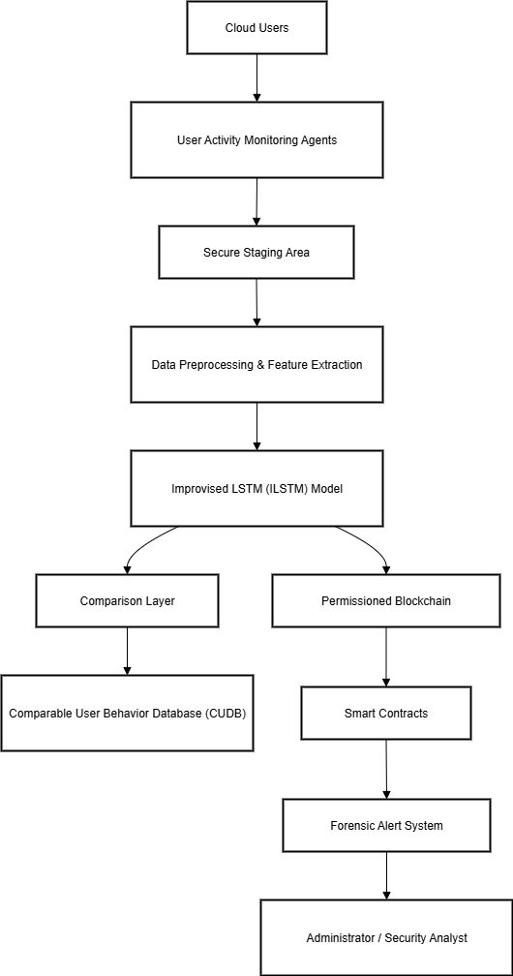
Fig.2. Architecture of the Proposed ILSTM-Based Insider Threat Detection Model
C. Ad hoc LSTM Model

The model is named Improvised Long Short-Term Memory ( ILSTM ) because of the modification of the classical one of LSTM, since the latter has been endowed with Comparison Layer in order to eliminate the disadvantages related to the user history either incomplete or absent, characteristic of both new and broken nodes. It is a Comparison Layer which is a Comparable User Behavior Database (CUDB) of hashed and validated behavior user account of like users. This all associated reference data is then stored safely in an archival fashion through a permissioned blockchain so that this cannot be altered in any way with tampering ability already, but yet is still of high-trust. Standard neural networks do not perform well with learning long dependency but the Recurrent Neural Networks (RNNs) partially solve this by means of feedback where the feedback loop itself learns only short term dependencies. Nevertheless, they on the contrary are worried by long-term behavior information. The Long Short-term Memory networks (LSTM) network also assist in addressing the issue with the mechanism of forget, input, and output gates that eliminate, add and store the information enabling to predict the user behaviour inside the time-series information. The Proposed ILSTM has a Comparison Layer where LSTM cell state is enriched by tested external behavioral input in the CUDB. This amplifies the correctness of the prophecy in the situations whereby less of the history data is applied. The state of the cell having modified ILSTMs is as:

------------------→(1)
whose inputted equivalent behavior is BiB_iBi which has been checked and stored irreversibly on the block chain to perform auditing on. The last trust factor is the subsuming of the ILSTM output, similarity index, and hashed-on-chain, transaction thresholds. This mixed-model will limit the occurrence of false alarms and enhance the accuracy of detection and maintain integrity of data and replace it with a more robust framework against insider attacks on cloud.
D. Update and Prediction equations
The ILSTM applies standard gated functions together with the comparison input to revise internal state. The major equations are:
Forget Gate:
--------------------------→(2)
Input Gate:
it=σ(Wi[ht−1,xt]+bi)i_t = \sigma(W_i [h_{t-1}, x_t] + b_i)it​=σ(Wi​[ht−1​,xt​]+bi​)

CandidateState: C~t=tanh⁡(Wc[ht−1,xt]+bc)\tilde{C}_t=\tanh(W_c [h_{t-1}, x_t] + b_c)C~t​=tanh(Wc​[ht−1​,xt​]+bc​)

Comparison Input:
Bi=σ(WB[ht−1,xt]+bB)B_i = \sigma(W_B [h_{t-1}, x_t] + b_B)Bi​=σ(WB​[ht−1​,xt​]+bB​)
Cell State Update:
Ct=ft⋅Ct−1+it⋅C~t+BiC_t = f_t \cdot C_{t-1} + i_t \cdot \tilde{C}_t + B_iCt​=ft​⋅Ct−1​+it​⋅C~t​+Bi​
Output Gate:
ot=σ(Wo[ht−1,xt]+bo)o_t = \sigma(W_o [h_{t-1}, x_t] + b_o)ot​=σ(Wo​[ht−1​,xt​]+bo​)
Hidden State Output:
ht=ot⋅tanh⁡(Ct)h_t = o_t \cdot \tanh(C_t)ht​=ot​⋅tanh(Ct​)

E. Trust Factor Calculation
TF that is now being calculated on-per-session basis will determine the amount of faith in user node. It is a combination of expected score, consistency of behavior and quantified transaction limits:
where:
- α,β,γ\alpha, \beta, \gammaα,β,γ are adjustable weights,
- BiB_iBi​ is the behavior similarity index,
- TltT_{lt}Tlt​ is the legal transaction threshold for the user.
- Any intermediate trust scores are hashed and inserted into the block chain under the traceability and immutable factor.[14][15]

F. Chain Storage, Hash verification
All behavior logs, resulting calculated trust factors, and final detection results must be hashed and permanently stored using a permission block chain, e.g. Hyper ledger Fabric. The integrity check is carried out by use of the following:
H local(X)=HBC(X)H_{local}(X)=H_{BC}(X)H local​(X)=HBC​(X)

where:
- Hlocal(X)H_{local}(X)Hlocal​(X) is the local hash of the behavior block XXX,
- HBC(X)H_{BC}(X)HBC​(X) is the appropriate hash in the block chain.
- Upon matching of the hashes, then data is trusted otherwise there is indication of tampering and that tampering is flagged.
G. Failed Node Discovery Algorithm
Algorithm 1Compromise of Block chain Aid ILSTM node detection
Inputs:
- utu_tut: looking at the clock
- TFTFTF: Trust Factor
- CUDBCUDsecdb: Compared User Behavior Data
Output:
The result of node classification
Procedure:
Check Monitoring Time:
If ut>Tthresholdu_t> T_{threshold}ut​>Tthreshold​:
→ Compute TFTFTF
Classify Node:
If TF>GTF > GTF>G: Node is Normal
Else:
Compute prediction score using ILSTM
If prediction score ≈ 0: Check for broken node
If prediction score > 0: Node is Suspicious/Malicious
Check Comparable Behavior:
If monitoring time is insufficient:
Retrieve BiB_iBi​ from CUDB
Compute:
If comparison score > 0 → Node is Normal
If comparison score < 0 → Node is Malicious
Else → Insufficient data
Final Trust Decision:
If ut>Tthresholdu_t> T_{threshold}ut​>Tthreshold​ and comparison indicates malicious behavior:
→ Node is Malicious
Store Result:
Keep all outputs and trust object on block chain
Send smart contract notifications, when necessary
End Procedure
H. Alert and Forensic Response
In case of suspicious behavior, an automatic notification is sent through smart contracts. This can be the closure of user sessions, secluding the node, or the re-authorization. All the trust factors, logs, and decisions are immortalized on-chain and thus security analysts have an audit verifiable evidence that can last forever and through audit, or compliance checks and or forensics analysis.[13]
VI.RESULTS AND DISUCUSSION
The Block chain-Assisted ILSTM Framework has been run on synthetic dataset containing 20, 000 user activity records to identify the insider threats in a more accurate and audit ability manner. The proposed method outperformed both standard LSTM (88 percent accuracy) and pure ILSTM (90 percent accuracy), and guaranteed tamperproof storage due to block chain as it has a reduced false positive rate of 5 percent. The trade-off is reasonable with slightly reduced throughput and inference time under block chain overhead to have better trust, verified alerts and good forensic tracking of cloud environments
.A. Overview of Dataset
The test set was the set of 20,000 real world scenarios under the form of user activity records.[12] The prevalence of normal, broken/ incomplete, as well as malicious insider nodes are indicated in Table 1.
TABLE I: Dataset Overview
Category | Description | Number of Records | Percentage
Normal Nodes | Verified users with consistent legitimate behavior | 14,000 | 70%
Broken/Incomplete Nodes | Users with incomplete or irregular behavior history | 4,000 | 20%
Malicious Insider Nodes | Users with suspicious or intentionally malicious actions | 2,000 | 10%

B. Comparison of the Performance Results
In order to come out with clear improvements, four were tested to be done as variants:
1. base case (Pure ML)
2. Standard LSTM
3. ILSTM Only
TABLE II: Performance Comparison
Metric | ILSTM Only | ILSTM + Block chain + CUDB
Detection Accuracy | 90% | 96%
False Positive Rate (FPR) | 8% | 5%
Tamper Detection Rate | Not applicable | 100%
Additional Overhead | Low | Moderate (acceptable trade-off)

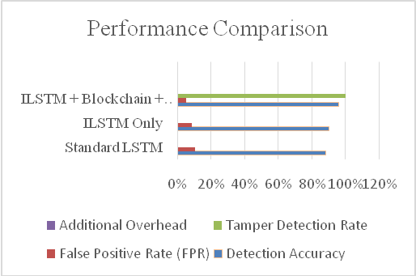
Fig.3. Performance Comparison Across Four Variants
C. Accuracy Point Matching
Table 3 illustrates the detection accuracy of each variant of the methods on a same workload condition in order to distinguish the improvement brought about. The ILSTM + Block chain model had an accuracy rate of 96 percent, FPR of 5 percent and a tamper rate of 100 percent. Qualitatively, the model was shown to be resilient to missing information on behavioral history and forensic audit ability.

D. Methodology Comparison
The contrast indicates that although the standard LSTM can learn the series of user behavior, it is incapable of addressing incomplete history as well as providing a secure storage. The ILSTM enhances its own detection methods by including a Comparison Layer but does not provide externally-verifiable data and can also be logged out. Such shortcomings are addressed by the proposed ILSTM with CUDB and block chain where verification of user behavior is anchored to trusted profiles and forensically sound results are immutably retrieved so that it detects more faithfully and forensically sound results are available
TABLE III : Comparison of Methodology
Variant | Handles Incomplete History | Comparable Behavior Data | Tamper-Proof Storage | Verified Alerts & Forensics
ILSTM Only | Partial | Internal patterns only | No | No
ILSTM + Block chain | Yes | Verified CUDB data | Yes (Block chain) | Yes (Smart contracts and audit)

E. Throughput & Inference Comparison
The suggested framework slightly reduces the throughput and increased inference time because it contains the additional steps of writing a block chain and verified CUDB lookup. Nevertheless, this sacrifice is worthwhile when it comes to enhancing trust, audit ability, and improved reliability in the overall detection levels that are considered to be provided by the standard LSTM techniques.
TABLE IV :Throughput and Inference Comparison
Variant | Throughput (records/sec) | Inference Time (ms)
ILSTM Only | 2300 | 35
ILSTM + Blockchain + CUDB | 2000 | 40

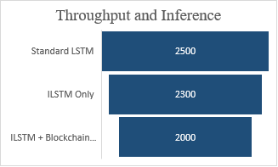
Fig.5. Throughput & Inference Comparison
The proposed ILSTM-Blockchain framework is more precise and reliable than the current systems like standard LSTM [3] and hybrid ML-based anomaly systems [8]. Integration of CUDB gives less reliance on past data which is a significant shortcoming of conventional models. In addition, the immutability of blockchain enhances the trust and auditor qualities that are non-existent in the traditional detection systems. These findings confirm that ILSTM-Blockchain is a quantifiably better approach to insider threat resilience.
VII. CONCLUSION AND FUTURE SCOPE
The suggested ILSTM with the help of Block chain proves to be a secure and verifiable model of insider threat detection in the cloud environment. The system continues to be highly detectable and accountable by combining deep learning in analyzing the time with immutable audit features of block chain. The usefulness of the framework in practice can be applied to cloud services, data centers, and federated infrastructures in an enterprise. Future projects are aimed at real-life applications, latency optimization, and suitability to IoT and edge computing applications.
VIII. REFERENCES
- Al- Mhiqani, M. N., Ahmad, R., Abidin, Z. Z., et al., Amaram, R. S., and Fernandez, P., 2020. A survey of insider threat detection: terminology, methods and problems on a large scale. Computers AND security, vol. 95. P. 101867.
- P. Walker-Roberts, R. A. Hammoudeh and A. Dehghantanha, A systematic review of insider threat detection research within critical healthcare infrastructures, Computers and Security, vol. 89, p. 101658, 2020.
- F. Ullah, S. U. R. Malik, S. Ahmad, M. A. Shah and Y. Cao, Data exfiltration: A survey of malicious insider threats and detection strategies, IEEE Access, vol. 8, pp. 67450-67470, 2020.
- M. Nazir, A. A. Minhas, S. A. Madani and A. A. Khan, Modeling, simulation and analysis of cyber attacks on SCADA systems, Computers and Security, vol. 92, p. 101760, 2020.
- L. Liu, Q. Zhang, X. Zhang, and M. Xu, A survey of insider threats: From APT intrusion kill chain to attacker profiling, IEEE Access, vol. 8, 2020, pp.130077130093.
- X. Chen, et al., User Behavior Analysis Based on Mouse Movements, for Insider Threat Detection, IEEE Access, 2020.
- Park, Y., et al., Keystroke dynamics and local outlier factor to detect anomalies [Online]. IEEE Access, 2020, 10.1109/ACCESS.2020.3019332.
- S. Young and Dahnert, DevEyes Framework: Insider threat detection using Bayesian belief networks, IEEE Access, 2020.
- N. Safa, R. Von Solms, and S. Furnell, Insider threats: intention modeling and influencing factors, Computers & Security, 2020.
[10]J. Pitropakis, et al., GPU-Accelerated Monitoring of Virtual Machines to Identify Insider Threats, IEEE Access, 2020.

[11] M. N. Al-Mhiqani, R. Ahmad, Z. Z. Abidin, el al., A New Intelligent Multilayered Framework of InsiderThreat Detection, Computers and Electrical Engineering, 97, 107597, 2022.

[12]Wang, Q. Sun, C. Zhou, Insider Threat Detection Based on Deep Clustering of Multi-Source BehavioralEvents. Applied Sciences, 13(24), (2023) 13021. https://doi.org/10.3390/app132413021[31]A

[13] Anju, K. Shalini, H. Ravikumar, P. Saranya, M. Krishnamurthy, (2023) Detection of Insider Threats Using Deep Learning. In 2023 3rd International Conference on Pervasive Computing and Social Networking (ICPCSN), IEEE, India. https://doi.org/10.1109/ICPCSN58827.2023.00050[32]F.

[14]Whitelaw, J. Riley, N. Elmrabit, A Review of the Insider Threat, a Practitioner Perspective Within the U.K. Financial Services. IEEE Access, 12, (2024) 34752-34768. https://doi.org/10.1109/ACCESS.2024.3373265[33]N.

[15]Kothari, C. Bhardwaj, S. Mishra, S. K. Satapathy, S.B. Cho, P. K. Mallick, (2024) Towards Insider Threat Resilience: A Proposed Mitigation Model. 2024 International Conference on Emerging Systems and Intelligent Computing (ESIC),Bhubaneswar, India.

[16]Dr.M.M.Karthikeyan, “Enhancing Mobile Network Security Through Blockchain Technology: A Zero Trust Approach Utilizing PoW, PoS, and BFT Algorithms”, IEEE Xplore, February 2025.

[17]A. Vinitha, S. Jeevitha, N.B. Mahesh Kumar, Sathish
Kumar L, Saravanan D, &quot; A Paradigm Shift in Real-Time
Detection: The YOLOv7 Approach to Trainable Freebie
Optimization&quot;, International Conference on Electronics and
Renewable Systems (ICEARS) - IEEE, 2025.

[18] N.Karthick and Dr. K.Ranjithsingh, "Enhancing WSN Reliability: A Survey of Security, Privacy, And Routing Strategies, Partners Universal International Innovation Journal (PUIIJ)",
Volume: 03 Issue: 03 , May-June 2025 , ISSN: 2583-9675.

​

